

PROJECT PROPOSAL

PROJECT GROUP NO:16 ACADEMIC YEAR: 2025-26
A. Proposed Title of the Project
AIMS-AI Meeting Summarizer
B. Introduction
In modern academic and professional environments, meetings, lectures, and seminars are conducted on a daily basis. Preparing minutes of meetings (MOM) or lecture notes manually is often time-consuming, inconsistent, and prone to human error. With the rise of online platforms such as Google Meet, Zoom, and Microsoft Teams, large volumes of transcripts are generated, but these raw texts are often lengthy, unstructured, and difficult to use directly.
AIMS – AI Meeting Summarizer is a rule-based NLP system designed to automatically generate structured minutes of meetings from such transcripts. The system preprocesses text by removing noise and filler words, applies keyword extraction and pattern-matching techniques, and produces clear outputs including concise summaries, key topics, decisions made, and action items. Unlike resource-heavy deep learning models, this lightweight approach ensures efficiency, explainability, and reliability.
The output minutes can be exported in PDF or DOC formats, making them easy to share and archive. By reducing manual effort and standardizing note-taking, AIMS saves time and ensures that critical discussions and responsibilities are captured accurately, while also laying a foundation for future integration with advanced AI/ML approaches.

C. Literature Review
The study Minutes of Meeting Generation for Online Meetings Using NLP & ML Techniques (2024) presents an approach that leverages natural language processing and machine learning to convert raw transcripts into structured meeting minutes. The system effectively identifies discussion points and decisions, providing high-quality summaries. However, its dependence on ML models makes it computationally expensive and less explainable, limiting adaptability in resource-constrained environments.

Jotter: An Approach to Summarize the Formal Online Meeting (2023) introduces a framework designed to capture essential highlights from formal meetings. Its strength lies in its structured output and focus on organizational settings. Nonetheless, the system struggles with conversational variability and informal language, which reduces its applicability to diverse meeting types.

The paper Meeting Summarizer Using Natural Language Processing (2022) employs NLP-driven extractive methods to produce concise summaries. Its major advantage is simplicity and efficiency, making it suitable for smaller-scale deployments. On the downside, extractive approaches often lead to redundancy and lack semantic coherence in the generated summaries.

In Action-item-driven Summarization of Long Meeting Transcripts (2023), the authors propose methods that focus explicitly on detecting and summarizing action items. This targeted approach ensures that critical responsibilities and deadlines are captured with high precision. The limitation, however, is that the broader meeting context is often underrepresented, resulting in summaries that are action-oriented but not fully comprehensive.
Finally, Summarizing Online Conversations: A Machine Learning Approach (2021) applies ML techniques such as topic modeling and frequency-based extraction to summarize group discussions. The approach is scalable and effective in handling noisy conversational data, a key strength for online environments. Yet, it is highly dependent on training data quality and often lacks explainability compared to rule-based systems.

D. Objectives
- To preprocess and clean meeting transcripts by removing filler words, repetitions, and irrelevant content, thereby converting raw text into a structured form suitable for analysis.

- To extract meaningful information such as key topics, decisions, and action items using rule-based NLP techniques like keyword extraction, TF-IDF/TextRank, and pattern matching.

- To generate and present structured minutes in the form of concise summaries, clearly defined decisions, and actionable to-do lists, with outputs available in standardized formats such as PDF or DOC.

E. Workplace |  | Address of Other Institute / Industry (if any):
College / Other Institute / Industry |  | Shri Madhwa Vadiraj Institute of Technology and Management
F. Requirement Details
1. Hardware | Laptop/PC with minimum Intel i5 Processor, 8GB RAM, 256GB SSD.
2. Software | Python 3.8+, PyPDF2, regex, Flask or Streamlit, python-docx, reportlab, Git.
3. Skill sets | Python programming, regular expressions, rule-based NLP logic, basic web (Flask/Streamlit) and database (SQLite) handling.
4. Others | Sample transcripts & annotated examples, relevant research papers, open-source datasets, consent/privacy guidelines.
G. Figure(s)/Drawing(s)
H. Methodology
The methodology for AIMS – AI Meeting Summarizer is divided into three sequential phases: Preprocessing, Rule-Based Extraction, and Assembly & Verification. The aim is to transform raw meeting transcripts into clean, structured, and validated minutes of meetings.
Phase I – Preprocessing
- Objective: Clean and prepare the raw transcript for further processing.
- Procedure:
  - Remove filler words, repetitions, and timestamps.
  - Normalize text by lowercasing, punctuation correction, and sentence segmentation.
  - Apply light annotation such as speaker tagging (if available), Named Entity Recognition (NER) for names and dates, and deadline normalization.
- Output: A set of well-structured, sentence-level transcript units with basic linguistic labels.
Phase II – Rule-Based Extraction
- Objective: Extract meaningful information using deterministic, explainable rules.
- Procedure:
  - Summarization: Use keyword scoring (TF-IDF/TextRank) to identify key sentences for a concise summary.
  - Decisions: Detect decision-cue phrases like “we decided”, “it was agreed”, or “approved”.
  - Action Items: Apply regex/pattern rules to capture tasks (e.g., “submit report by Friday”) with responsible persons (from NER or speaker labels) and deadlines.
- Output: Ranked summary sentences, key topics, decisions, and action items with associated confidence scores.
Phase III – Assembly & Verification
- Objective: Organize extracted content into structured minutes and validate accuracy.
- Procedure:
  - Compile results into canonical sections: Title, Date/Time, Participants, Key Topics, Summary, Decisions, and Action Items.
  - Present extracted decisions and tasks with confidence indicators for quick human verification and corrections.
  - Store finalized minutes in a searchable format for future retrieval and continuous improvement.
- Output: Verified, structured minutes of meeting ready for sharing and archival.
Evaluation & Iteration
- Quality Measures: Precision, Recall, and F1 for extraction tasks; ROUGE and human judgment for summaries.
- Improvement Loop: User corrections are logged and used to refine rules and thresholds over time.

I. Flowchart (Plan of Action)
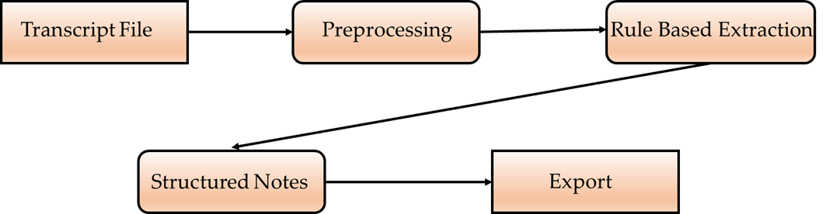
J. Expected Outcome of the project
- Automated generation of meeting/class minutes in a structured format.
- Standardized notes with:
  - Key Topics
  - Decisions
  - Action Items (Who, What, When)
- Saves time and reduces human errors.
- Exportable as PDF/DOC for easy sharing.
- Prototype for AI-based summarizer, extendable to ML/DL models in future.

K. References
- • Banerjee, D., Kumar, R., & Basu, A. (2024). Minutes of Meeting Generation for Online Meetings Using NLP & ML Techniques. IEEE. Available at: https://ieeexplore.ieee.org/abstract/document/10497256/
- • Patel, Y. D., & Jivani, M. (2023). Jotter: An Approach to Summarize the Formal Online Meeting. IEEE. Available at: https://ieeexplore.ieee.org/abstract/document/10390455/
- • Li, M., Xu, S., & Li, J. (2022). Meeting Summarizer Using Natural Language Processing. IEEE. Available at: https://ieeexplore.ieee.org/abstract/document/9777155/
- • Zhang, Y., et al. (2023). Action-item-driven Summarization of Long Meeting Transcripts. ACM. Available at: https://dl.acm.org/doi/abs/10.1145/3639233.3639253
- • Sood, A., Sharma, S., & Yadav, P. (2021). Summarizing Online Conversations: A Machine Learning Approach. ResearchGate. Available at: https://www.researchgate.net/publication/372988411_Summarizing_Online_Conversations_A_Machine_Learning_Approach

L. Project Batch members
S.No. | USN | Name |  | Signature with date
1. | 4MW23CS080 | NAYANA K
2. | 4MW23CS085 | NIKITHA
3. | 4MW23CS102 | PRATHIKSHA
4. | 4MW23CS130 | SAKSHI H C
M. Accepted/Rejected:
N. Suggestions for implementation:
P. Guidance
Guide (s) allotted |  |  | Guide Name and Signature (s) with date
1. Guide

Q. Review Comments/Suggestions

Accept/Modify/Reject

Reviewer Name and Signature

